

Anti-Bullying Policy
Written by the School Council

At Ashton Keynes C of E Primary School, we want to make everyone feel welcome, happy and well treated. Because of this we don’t think we have any bullies in our school.
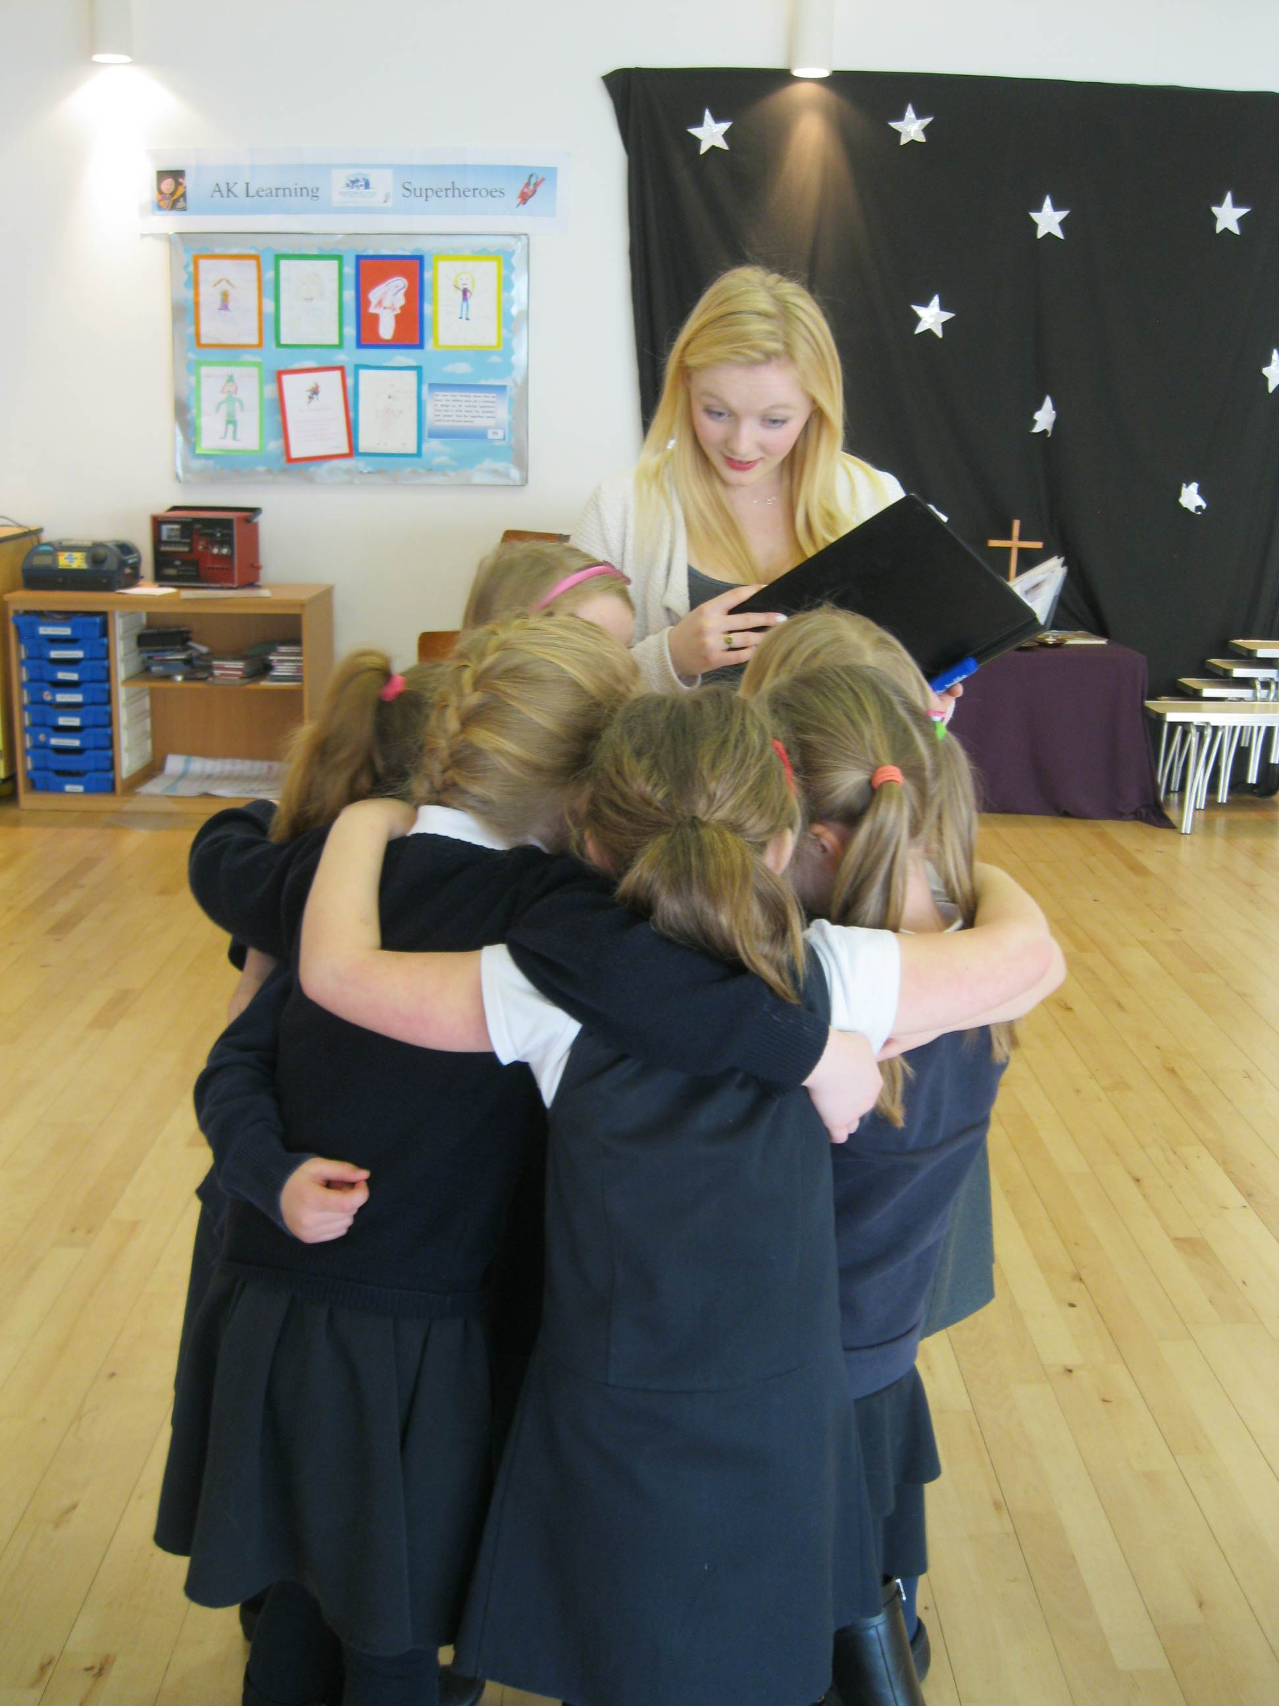
We think that a bully is someone who would -
- Say unkind things repeatedly to the same person so that they feel unhappy.
- Physically hurt someone over and over again.
- Use racist, cultural or religious remarks.
- Use threatening or unkind behaviour on purpose to make someone sad.
- Make someone feel different on purpose.

If someone is feeling that they are being bullied they should –
- Tell someone they trust e.g. a teacher, a parent, a carer, a TA, an adult they know well, or a friend.

If someone sees someone being bullied they should –
- Convince them to tell someone about it, or maybe even tell someone on their behalf, so it’s not just ignored.
- Invite them to play a fun game and make them feel better.
- Help them not to be mean back.

We think that if someone is bullying another person it may be because they are unhappy, or maybe even that they have been bullied in the past. An adult should try and talk to the person doing the bullying and try to find out why they are doing it so that they will stop.
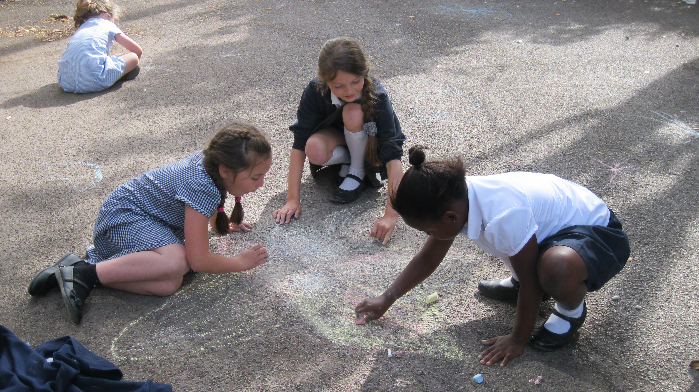
Remember –
‘Don’t be scared, Be prepared’

ddd

