Ashton Keynes Primary School: Pupil Premium 2015-2016
The 2015/2016 PPG – FSM and LAC budget was £22,280
How the 2015/2016 PPG – FSM and LAC was spent....
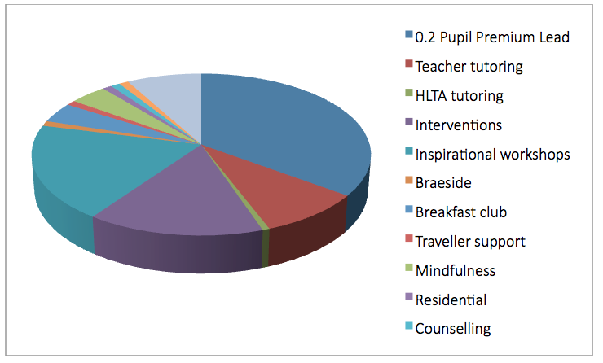

The 2015/2016 PPG – Service budget was £2,100
How the 2015/2016 PPG – Service was spent....
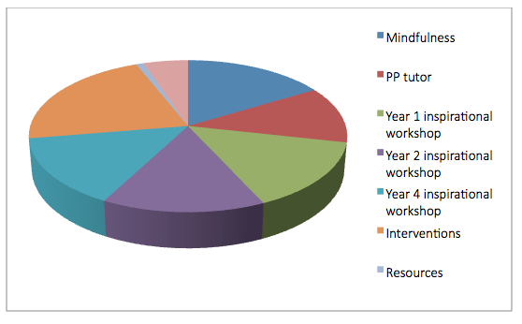

Click here to read the spending breakdown, rationale behind each spend and the impact it made.

The progress impact of the PPG- FSM and LAC
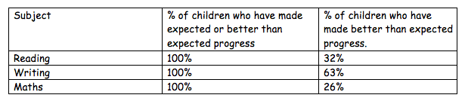
In summary, all children who have made better than expected progress have made clearly identified progress in terms of their steps of progress. This has been measured on Target Tracker, from their initial assessment in Autumn to the end outcome in the Summer, 5 steps progress was deemed to be exceeding expected progress.

