

Welcome to the 4th edition of *The Whisperer*! This month (March) we have definitely had a lot of exciting experiences ( e.g. the Lunar Eclipse , Red Nose Day all sorts of things!) So to find out more about this month, read on !

*March 2015*

**Edition 4**

**THE WHISPERER**

Recently, Mrs Crowley and Mrs Saville , using money kindly given to the school by the Ashton Keynes music festival, bought us 10 BRAND NEW, PROPER Steel Pan Drums. Steel Pan Drums are a common sight on Caribbean beaches and make a lovely sound. Already Years 5 and 6 can play them, Y6 performing on the Playground. The Steel Pan Drums can only be played with what you call a beater but is actually called a Mallet. Y5 will be performing later on in the year so good luck to them . Will they be better than the Y6 class?

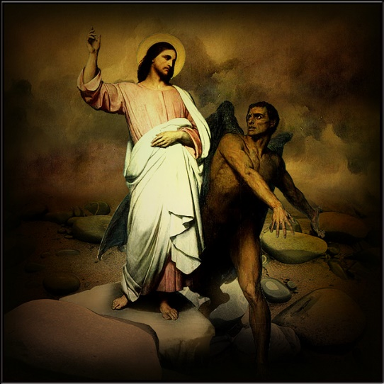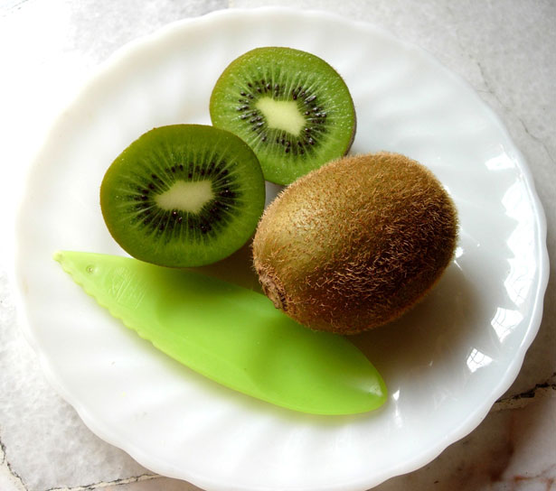[](http://funnypictures.co.uk/image/113408115439)

This edition we were lucky enough to have Reverend Shirley help us out with this article. A massive thank you to Reverend Shirley for coming to see us…

**What Is Lent?**

1. Lent comes from the word lengthening because it`s at the time when the days are getting longer.
2. It`s 40 days long and it doesn’t include Sundays because we`re remembering the 40 days that Jesus spent in the desert , when he was preparing himself to do Gods work of teaching , healing and gathering his disciples.
3. It`s a time of spring cleaning our hearts. So they`re ready to celebrate Jesus dying and rising at Easter.

**Why do people give things up in Lent?**

People do it so they can focus on God. Rather than lots of meals they have simple food that Builds up to a nice big meal at Easter and you can really celebrate Jesus coming alive again.

**Why are the dates so important and what are the dates?**

Lent is 40 days plus the Sundays before Easter. Because the date of Easter changes (it changes because of the Moon) the date of Lent also changes.

**What is the story of Lent ?**

The Bible story behind Lent is the time when Jesus was in the Desert and the Devil tempted Jesus to do spectacular things for himself . One of those was to turn Stones into bread and another was to worship the Devil. Jesus didn`t do any of those things , he remembered what God would want him to do.

**What is Shrove Tuesday ( Pancake day) got to do with Lent?**

People long ago would eat most of the food they wouldn`t eat during the fast for Lent as they would be fasting. In French , Pancake day is known as Mardi Gras ( Fat Tuesday.) Lent starts the following day on Ash Wednesday.

Year 3 and 4 have been noticed AGAIN for doing some great work! This time it isn`t a mosaic though. Instead , it is for the amazing play ( Jack And The Beanstalk, Roald Dahl) they perform on the 20th March. The play had moving props without anyone moving them , it had a lot of ` get you moving` songs. Overall , the play was extremely excellent. Also , the teachers and TA`s helping did a great job as did the lighting and music ! See the class pages for more information.

COMPETION!

*The Whisperers* 4th challenge is to design and make whatever you like out of PlayDo or Lego. It should be appropriate for School and be completely your ideas (not building from an instruction set. Also, make sure that it is under 30cm high and 30 cm wide. Whoever enters will get a small prize for taking part and then the overall winner for each age group (see below) will get the main prize, you will find out what this is when it is presented. Please hand in to Oliver, Y6, before the 17th April 2015. The prize categories are , YR,Y1,Y2 another category is Y3 and Y4 , then finally Y5 and Y6. GOOD LUCK, ENJOY AND PUT YOUR BUILDING HATS ON!

“Justice will not be served until those who are unaffected are as outraged as those who are.”   
― Benjamin Franklin

Kiwis appear rather peculiar looking fruits; on the outside and inside, but really they are one of the most delicious fruits available (only if you like sour flavours!) Kiwis are a sour tasting fruit with a white core in the middle. When ripe, the core is soft and juicy however when it isn`t raw then it is hard and flavourless. Before cutting the Kiwi, squeeze each one gently the softest one is the

ripest, the hardest being the hardest. You can eat Kiwi on their own but they also go deliciously in a fruit Smoothie. You can buy Kiwis anywhere, so go shopping and by some Kiwis…

**FRUIT OF THE MONTH**

Did you see the Lunar Eclipse on the 20th of March? If you didn`t, check out the BBC website for more information on dates and effects!

"If you take yourself out of the game you will never succeed." - Unknown

We chose this picture as it is extremely funny. It is a typical dog thing to do and is what I am sure all dogs would do!

The sport of the month is swimming. Swimming, is a great sport involving water. If you can swim you can do all sorts of things – go to waterparks, go sailing all sorts. However if you want to take swimming to another level, you can join a club and start swimming competitively. Swimming can be taught at all different stages, all levels. In addition to many people liking it, it is one of the most popular sports for getting fit. Get to your nearest swimming pool (either Lime Kiln in Wootton Basset or Cirencester Leisure) and swim!

**KIWI**