Year 1 | Week 1 | Week 2 | Week 3 | Week 4 | Week 5 | Week 6 | Week 7 | Week 8 | Week 9 | Week 10 | Week 11 | Week 12
Autumn term | The human body  Focus five  sound  sight  taste  sense  touch  Texts  Marvellous Body: A Magic Lens Book  Jane Wilsher & Andres Lozano  Get Into Science: The Five Senses  Jane Lacey & Sernur Isik  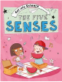  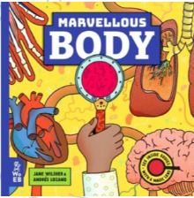  Inventor  Louis Braille  The incredible story of the boy who invented Braille - BBC Ideas   Forest school learning opportunities  Step 4 Sound walk |  |  |  |  | Seasonal change  Autumn | Materials  Focus five  Texts  Scientist |  |  |  |  | Seasonal change  Winter
Spring term | Planting A  Focus five  Texts  Scientist | Animals  Focus five  Texts  Scientist |  |  |  |  |  | Caring for the planet |  | Seasonal change Spring | Planting B  Focus five  Texts  Scientist | Consolidation
Summer term | Plants |  |  |  |  | Planting C | Growing and cooking |  |  | Seasonal change  Summer | Consolidation

