Year 2 | Week 1 | Week 2 |  | Week 3 | Week 4 |  |  | Week 5 | Week 6 | Week 7 |  | Week 8 |  | Week 9 |  | Week 10 | Week 11 |  | Week 12
Autumn term | Animal needs for survival  Focus Five  survival  mammal  amphibian  reptile  shelter  Text  The Most Important Animal of All  Penny Worms & Hannah Bailey  The Big Book of Beasts  Yuval Zommer  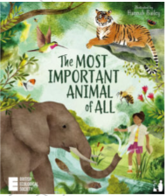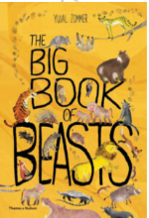  Naturalist  Steve Backshall  STEVE BACKSHALL   Forest school learning opportunities  Step 1 Create an area within the school grounds to provide food and water for a range of mammals. Whilst creating this area, children should explain why and how this area helps local mammals meet their needs for survival.  Step 2 Bird survey, Bird feeders  Step 4 Pond |  |  |  |  |  | Humans  Focus Five  Text  Scientist |  |  | Materials  Focus Five  Text  Scientist |  |  |  |  |  |  |  |  | Plastic
Spring term | Plants (light and dark) |  |  |  |  | Living things and their habitats |  |  |  |  |  |  |  |  |  |  |  | Light and dark | Consolidation
Summer term | Plants (bulbs and seeds) |  | Growing up |  |  |  |  |  |  |  | Bulbs and seeds |  | Growing up |  | Wildlife |  |  | Consolidation

