Year 3 | Week 1 | Week 2 |  | Week 3 | Week 4 | Week 5 | Week 6 |  |  | Week 7 | Week 8 |  | Week 9 |  | Week 10 |  | Week 11 | Week 12
Autumn term | Skeletons  Focus Five  skeleton  protection  support  bones  movement  Text  Funny bones by Janet and Allan Ahlberg  Muscles and movement by Izzi Howell  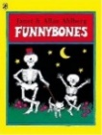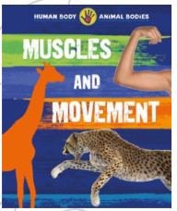  Scientist  Wilhelm Rontgen discovered Xray  Wilhelm Röntgen - Biography, Facts and Pictures (famousscientists.org)    Forest school learning opportunities  Step 4 explore and identify animals with or without a spine in an outdoor environment. |  |  |  | Movement | Nutrition and diet  Focus Five  Text  Avocado Baby by John Burningham  I will not ever never eat a tomato by Lauren Child  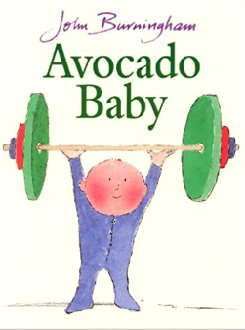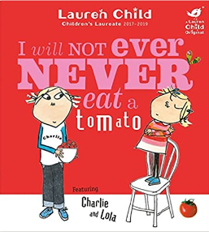  Scientist  Adelle Davis nutritionist  Adelle Davis | Adelle Davis Foundation |  |  |  |  | Food waste |  |  | Rocks  Focus Five  Text  The pebble in my pocket by Meredith Hooper  A rock is lively by Dianna Hutts Aston  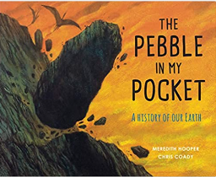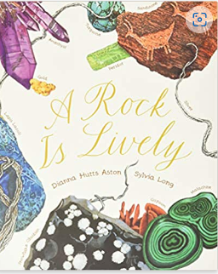  Scientist  Dr Anjana Khatwa geologist  Dr Anjana Khatwa - Knight Ayton |  |  |  | Consolidation
Spring term | Fossils |  | Soils |  |  |  |  | Light |  |  |  |  |  |  |  |  |  | Consolidation
Summer term | Plants A |  |  |  |  |  |  |  | Forces |  |  | Magnets |  |  |  | Plants B |  | Biodiversity

