Year 5 | Week 1 | Week 2 | Week 3 | Week 4 |  | Week 5 |  | Week 6 | Week 7 | Week 8 |  | Week 9 |  |  | Week 10 | Week 11 |  | Week 12
Autumn term | Forces  Focus Five  force  friction  air resistance  gravity  water resistance  Text  The gravity tree  Anna Crowley Redding  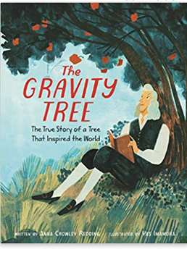  Scientist  Galileo Galilei  Isaac Newton  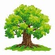 Forest school learning opportunities  Step 5 Air resistance- Paper helicopters can be made and compared to designs seen in nature, such as a sycamore seed. |  |  |  |  |  |  | Space  Focus Five  Text  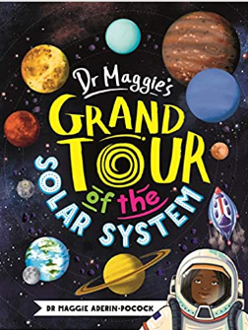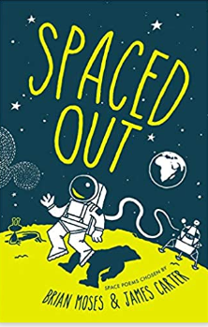  Scientist  Tim Peake  Home - Tim Peake |  |  |  |  |  |  |  | Global warming |  | Consolidation
Spring term | Properties of materials |  |  |  |  |  | Animals including humans |  |  |  |  |  |  | Life cycles
Summer term | Reproduction A |  |  |  | Reversible and irreversible changes |  |  |  |  |  | Plastic pollution |  | Reproduction B |  |  |  | Consolidation

