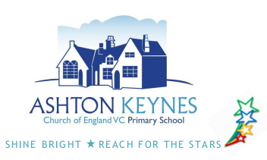
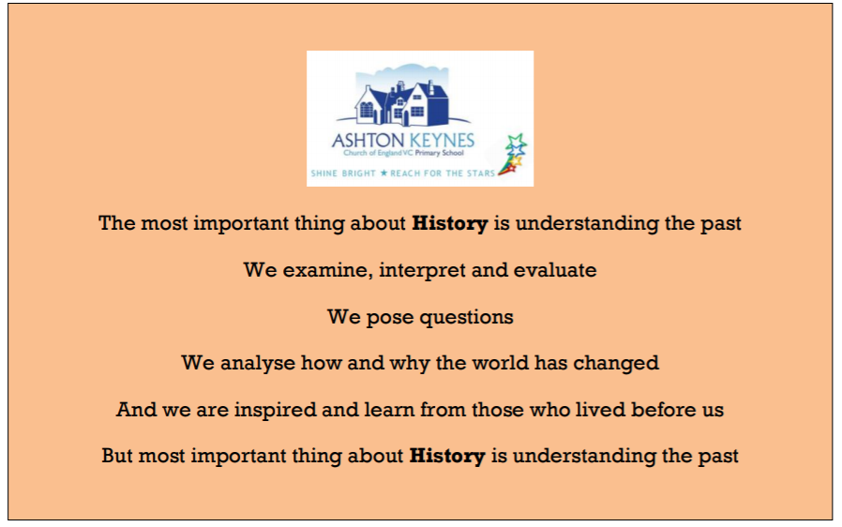


Our Christian vision:
‘The journey to life in all its fullness’

This policy will be reviewed every two years by the History subject leader and shared with all stakeholders.

Date: Nov 2025 To be reviewed: Nov 2027

Our vision for History at Ashton Keynes Primary School:

Our intent:

At Ashton Keynes Primary School, we provide a high-quality history curriculum that has been carefully designed and sequenced to equip children with a secure, coherent knowledge about British, local and world history. Our History Shine Curriculum is knowledge, vocabulary and experience rich, delivered in a sequenced chronological order, allowing children to develop their understanding of historical concepts as they move through the school. Our curriculum reflects our locality and endeavours to ensure that children are knowledgeable about their locality’s history and the changes it has seen. We believe that history fires pupils’ curiosity about the past in Britain and the wider world. We aim to bring history to life and to instil a desire to understand the past. Children will understand historical events in chronological order. Chronological understanding is key and enables children to be able to place events and people both within and across historical periods, identifying similarities and differences throughout history. We view history as a great deal more than learning facts: we see it as an opportunity to pose questions, analyse how and why the world has changed, to become open minded “historical experts” and explore the past. Here at Ashton Keynes, we want children to be inspired from those who lived before us.

Termly and half termly topics give scope for cross curricular work. Through history, children learn to make comparisons and links between the past and modern times and discover how and why things have changed. They learn about people and events in the past, in Britain and the wider world, and realise that these have influenced our lives today.

Curriculum Concepts:

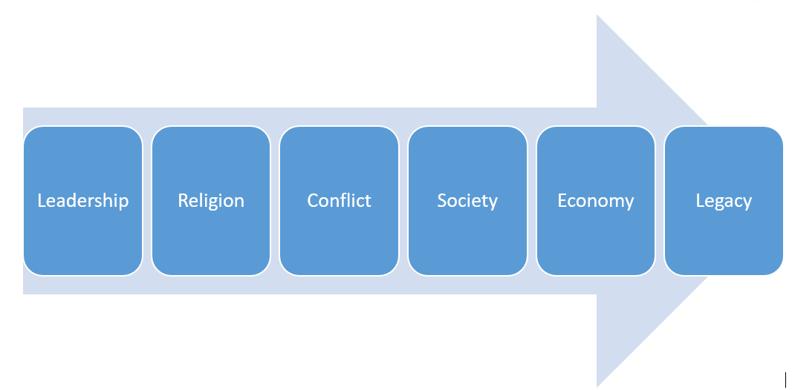
Within our curriculum, we have identified a set of key curriculum ‘concepts’ that children will revisit throughout their time at Ashton Keynes Primary School. Our curriculum concepts are as follows: leadership, religion, conflict, society, economy, legacy. Each history unit will not include every ‘concept’, but they will be revisited regularly by the children throughout their AKPS journey. For example, in Year 3, children will encounter the concepts of leadership, religion, society and legacy when studying the Ancient Egyptians. In Year 6, children will revisit the concepts of religion, society and legacy when they explore the Ancient Greeks.

Historical Concepts:

Within our curriculum, we have identified a set of key historical ‘concepts’ that children will revisit throughout their time at Ashton Keynes Primary School. Our historical concepts are as follows: chronology, similarity and difference, cause and consequence, historical interpretation, historical vocabulary, organisation and communication, historical enquiry. Similarly to our curriculum concepts, the historical concepts will be revisited regularly by the children throughout their AKPS journey and some history units will cover more than one concept, allowing the children to work as historians.
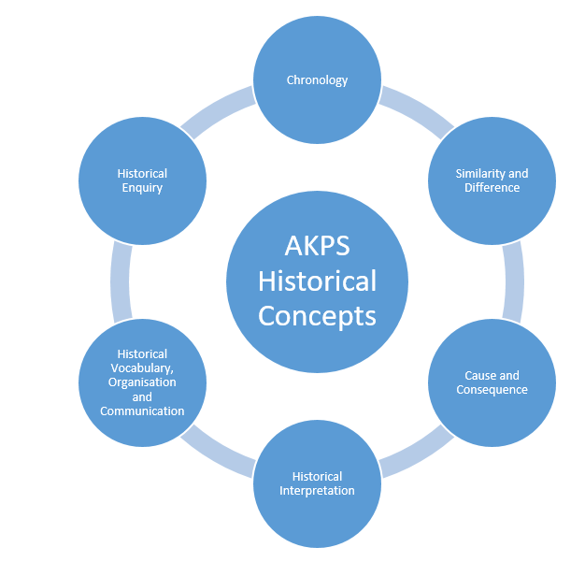

Our implementation:
The starting point of any study should usually be within the children’s own experience, and incorporate a timeline to ensure that their understanding of chronology is paramount.
The course of study for History will develop the following key elements, ensuring that all children:

- know and understand the history of these islands as a coherent, chronological
narrative, from the earliest times to the present day: how people’s lives have shaped
this nation and how Britain has influenced and been influenced by the wider world
- know and understand significant aspects of the history of the wider world: the nature of ancient civilisations; the expansion and dissolution of empires; characteristic features of past non-European societies; achievements and follies of mankind
- gain and deploy a historically grounded understanding of abstract terms such as ‘empire’, ‘civilisation’, ‘parliament’ and ‘peasantry’
- understand historical concepts such as continuity and change, cause and consequence, similarity, difference and significance, and use them to make connections, draw contrasts, analyse trends, frame historically-valid questions and create their own structured accounts, including written narratives and analyses
- understand the methods of historical enquiry, including how evidence is used rigorously to make historical claims, and discern how and why contrasting arguments and interpretations of the past have been constructed History – key stages 1 and 2 2
- gain historical perspective by placing their growing knowledge into different contexts, understanding the connections between local, regional, national and international history; between cultural, economic, military, political, religious and social history; and between short- and long-term timescales
History National Curriculum
Children in Key Stage 1 should be taught:
- Changes within living memory. Where appropriate, these should be used to reveal aspects of change in national life
- Events beyond living memory that are significant nationally or globally [for example, the Great Fire of London, the first aeroplane flight or events commemorated through festivals or anniversaries]
- The lives of significant individuals in the past who have contributed to national and international achievements. Some should be used to compare aspects of life in different periods [for example, Elizabeth I and Queen Victoria, Christopher Columbus and Neil Armstrong, William Caxton and Tim Berners-Lee, Pieter Bruegel the Elder and LS Lowry, Rosa Parks and Emily Davison, Mary Seacole and/or Florence Nightingale and Edith Cavell]
- Significant historical events, people and places in their own locality.
Children in Key Stage 2 should be taught:
- changes in Britain from the Stone Age to the Iron Age
- the Roman Empire and its impact on Britain
- Britain’s settlement by Anglo-Saxons and Scots
- The Viking and Anglo-Saxon struggle for the Kingdom of England to the time of Edward the Confessor
- A local history study
- A study of an aspect or theme in British history that extends pupils’ chronological knowledge beyond 1066
- The achievements of the earliest civilizations – an overview of where and when the first civilizations appeared and a depth study of one of the following: Ancient Sumer; The Indus Valley; Ancient Egypt; The Shang Dynasty of Ancient China
- Ancient Greece – a study of Greek life and achievements and their influence on the western world
- A non-European society that provides contrasts with British history – one study chosen from: early Islamic civilization, including a study of Baghdad c. AD 900; Mayan civilization c. AD 900; Benin (West Africa) c. AD 900-1300.
Historical Skills Progression
Progress in history can be characterised by:
asking and answering more complex questions;
making links and connections between different areas of learning;
recognising patterns and categorising;
understanding more abstract concepts;
providing more reasoned explanations;
understanding what is more or less important;
appreciating the relevance of learning;
using a greater depth and range of historical knowledge to back up judgements;
becoming an independent learner.

Assessment

The three- star challenge – which is used in all subjects and lessons - is a key assessment tool providing an immediate indication of a child’s knowledge and understanding. It allows teachers to identify common misconceptions, strengths and next steps for individuals and the whole class.
We have a range of ways to find out what the children know. In Early Years children are assessed using the Development Matters descriptors for Understanding the World (personal and family history, ‘then and now’ and exploring objects and images from the past). Teachers use their knowledge gained about each child through observations, assessments and interactions to make their own judgements termly. Regular assessment occurs which informs planning and next steps. A profile assessment is completed at the end of the year to support a successful transition into KS1 and inform parents.

From Year 1 onwards, we know the children are making progress in history because we regularly revisit prior learning including the Focus 5 vocabulary. We observe and question children during whole class group and independent activities to check their understanding of concepts and skills. Questioning is used to further deepen their understanding and thinking skills.

Each unit is structures around 5 key words, known as our Focus Five. These act as hooks in which children can pin core knowledge, allowing them to make links with both prior learning and a range of periods throughout history. Teachers use the Focus Five throughout each topic, revisiting them consistently, allowing children to become familiar with each word and its meaning. This method is used to assess children’s understanding of both the current topic, and of their awareness of similarity and difference and cause and consequence linked to other units they have studied previously. Teachers also have one or two key questions linked to their topics which, like the Focus Five, can be revisited in order to assess children’s retention of key knowledge. Each unit concludes with an end-of-unit quiz that draws together the Focus Five and wider knowledge, providing a clear picture of pupils’ retained understanding and progress over time.

Where appropriate an extended piece of writing is a tool that is used to assess the children’s knowledge and understanding.

Recently, in January 2022, a new timeline was installed outside at Ashton Keynes. This timeline is used to develop chronological understanding. It can be referred to at the start of each topic, and teachers can link new learning to previous learning, in line with the whole school knowledge and skills progression map. In addition to this, when in KS2, children’s history books move through the school with them, meaning that they can revisit previous learning. This includes a timeline in the front of their books, where they can add details about each civilisation they study, and understand where they fall within their wider understanding of other civilisations, and ultimately, chronology.

Equal Opportunities:

At Ashton Keynes, we are committed to providing a teaching environment which ensures all children are provided with the same learning opportunities regardless of social 7 class, gender, culture, race, special educational need or disability. Teachers use a range of strategies to ensure inclusion and also to maintain a positive ethos where children demonstrate positive attitudes towards others. Support for specific individuals is well considered and planned for, with consideration given to how greater depth and further challenge can be provided for and demonstrated by children who require further challenge.

Inclusion:

All pupils are entitled to access the History Shine Curriculum at a level appropriate to their needs. To ensure inclusion, teachers use a range of strategies in line with the school’s inclusion planning key. Independent tasks, as well as teaching, are also well-adapted to ensure full accessibility; these are designed and selected to provide appropriate challenge to different groups of learners. The school makes full use of additional adults who are deployed effectively to ensure that identified individuals and specific groups of children are able to make progress according to their full potential. The wide and varied range of learning experiences, including access to places of historical significance in the immediate and wider locality, as well as bespoke workshops, ensures a broad, balanced and enjoyable history curriculum that considers all learners.

Role of the Subject Leader:

The subject leader’s responsibilities are:
● To ensure a high profile of the subject across the school.
● To ensure a full range of relevant and effective resources are available to enhance and support learning including the Wiltshire Learning Hub.
● To model the teaching of history
● To ensure progression of the key knowledge and skills identified within each unit and that these are integral to the programme of study and secure at the end of each age phase.
● To monitor books and ensure that the key knowledge and, where applicable, key skills, are evidenced in outcomes.
● To monitor planning and oversee the teaching of history.
● To ensure that the history curriculum has a positive effect on all pupils, including those who are disadvantaged or have low attainment.
● To ensure that the history curriculum takes account of the school’s context, promotes children’s pride in the local area and provides access to positive role models from the local area to enhance the history curriculum.
● To ensure that approaches are informed by and in line with current identified good practices and pedagogy and to attend regular opportunities for CPD.

Monitoring

Monitoring in history includes regular book looks, lesson observations and/or learning walks, providing opportunities for pupil voice and analysing data. We do this in order to ensure correct curriculum coverage, share good practise, encourage a high quality of teaching and learning as well as ascertaining children’s attitudes to learning geography. This information is then used to inform further curriculum developments and provision is adapted accordingly.

